ENG1DI News Report

Task: Write a news report based on the provided picture and headline below. You will have to
use the facts and information from the novel.

Purpose and Audience: to report on an event for the readers of a newspaper

Length: 250-300 words

Serious House Fire in Maycomb
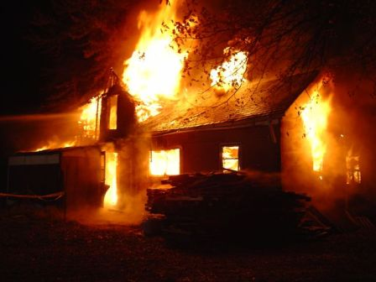

Paragraph One: The Lead/Basic Facts (try for one or two sentences). Make them up (but stay realistic).
.
Who
What
Where
When

Paragraph Two: The Why Analysis
Why did the incident or event happen?

Reveal important
aspects of the
back story

Paragraph Three: The How Analysis
How did the incident happen or event come about?

This is where you include all of the details

Paragraph Four: Quotations
Invent two quotations from two different characters to use in your article.
Quotation #1 | Quotation #2

Paragraph Five: The Finish
Answer the question:
What happens next?

Tie up any “loose ends”

Include any extra information that you think would add to your article and make it more enjoyable to read, but do not make up false details.

Evaluation of News Report Name: ________________________________

 | Level 4 | Level 3 | Level 2 | Level 1 | Below Level
Lead Sentence/ Paragraph  Who? What?  Where? When? | Lead sentence/paragraph states the crucial facts clearly, concisely, effectively | Lead sentence/paragraph states the basic facts clearly and concisely | Lead sentence/paragraph states some basic facts clearly and concisely | Lead sentence/paragraph states few basic facts clearly and concisely | Lead sentence/paragraph is not clear, does not follow conventions
Content: Body  Why? How?  Development of Information  Uses quotations | Clearly and creatively explains how and why using facts and imagination | Explains how and why with facts and some imagination | Explains how or why to some extent using mostly facts but also some imagination | Rarely explains how and why; news report does not contain enough information | Does not explain how and why; information is superficial
 | Effectively uses/integrates quotations to support key points in a highly imaginative yet believable manner | Uses/integrates quotations to support key points in a believable manner | Uses some quotations to support key points; perhaps problems with integration | Uses quotations to support key points; problems with integration; quotations are unrealistic | Does not use facts and/or direct or indirect quotations
Style Elements  including tone, point of view, language choices (appropriate to news report audience) | Consistently uses a polished and professional tone that suits the form | Consistently uses an objective tone and point of view | Uses an objective tone and point of view somewhat consistently | Inconsistently uses an objective tone and point of view | Does not use an objective tone and point of view
 | Effectively uses language and style appropriate to intended audience | Uses language and style appropriate to intended audience | Inconsistently uses language and style appropriate to intended audience | Uses language and style inappropriate to intended audience | Uses language and style very inappropriate for intended audience
Language  Conventions  (spelling, punctuation, use or proper tense – past, sentence structure) | Consistently uses language conventions correctly, flawless or nearly so | Usually uses language conventions correctly; minor errors evident | Sometimes uses language correctly; a few major and minor errors evident | Rarely uses language conventions correctly; several major and minor errors evident | Does not use language conventions correctly; several major errors evident

Comment:

